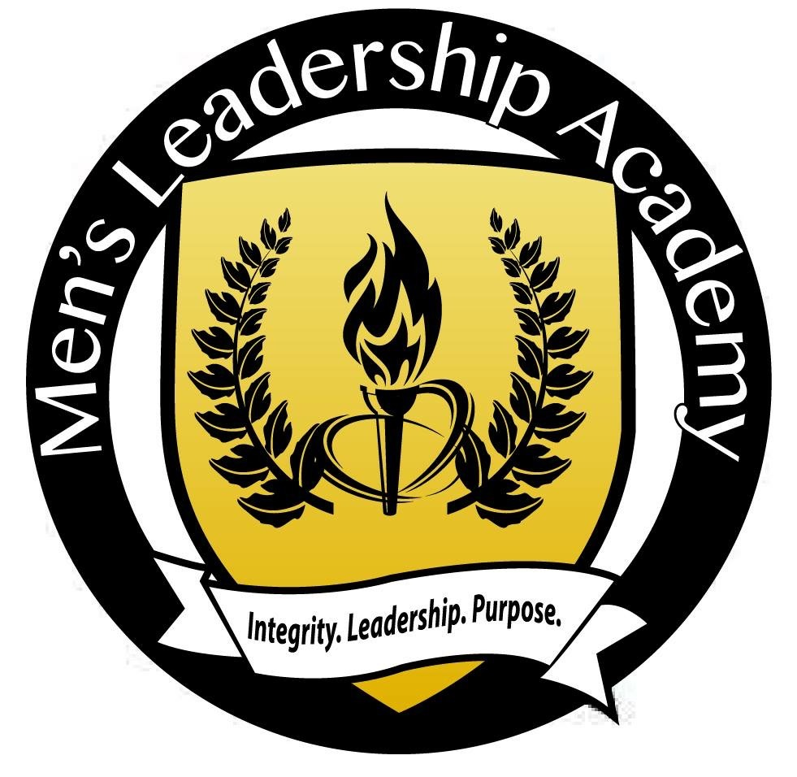

Men’s Leadership Academy
Haircuts for Literacy

“Life’s most persistent question is-What are we doing for others?”
- Dr. Martin Luther King, Jr.

The Sacramento City Unified School District Youth Development Support Services (YDSS) is investing in Summer with the implementation of our new “Haircuts for Literacy” program. The goal of this program is to encourage our students, ages 5-12, to continue educating their mind during the summer months. It is our hope that your barbershop will join us in our efforts by agreeing to become a Men’s Leadership Academy (MLA) Barbershop. By becoming a MLA Barbershop, your barbershop will agree to:
- Provide 10 FREE haircuts a month (June-July-August) 30 FREE haircuts over the summer.
- Allow the student(s) to read to you before giving the students a free haircut.
- Provide praise and acknowledgement of these students in your barbershop.
Our goal as an YDSS department is to have 300 students read 300 books for 300 haircuts. The name of this campaign will be #Inspire300 with additional hashtags like, i.e. #InvestinSummer #HaircutsforLiteracy #BarbershopReads

If you agree to become a Men’s Leadership Academy Barbershop, we will provide you with marketing and branding materials for your shop. We will also provide a number of books for your barbershop for the students to read.

It is our hope that you will join us in our #Inspire300 Campaign! Thank you for the opportunity to share our passion for our students with you!

_ Our Barbershop will join you for the #Inspire300 Campaign Summer 2016

_ Our Barbershop will NOT be able to join you for the #Inspire300 Campaign Summer 2016

Men’s Leadership Academy
Integrity. Leadership. Purpose.
#MLALegacy

