Student Advisory Council
2020-2021 Application

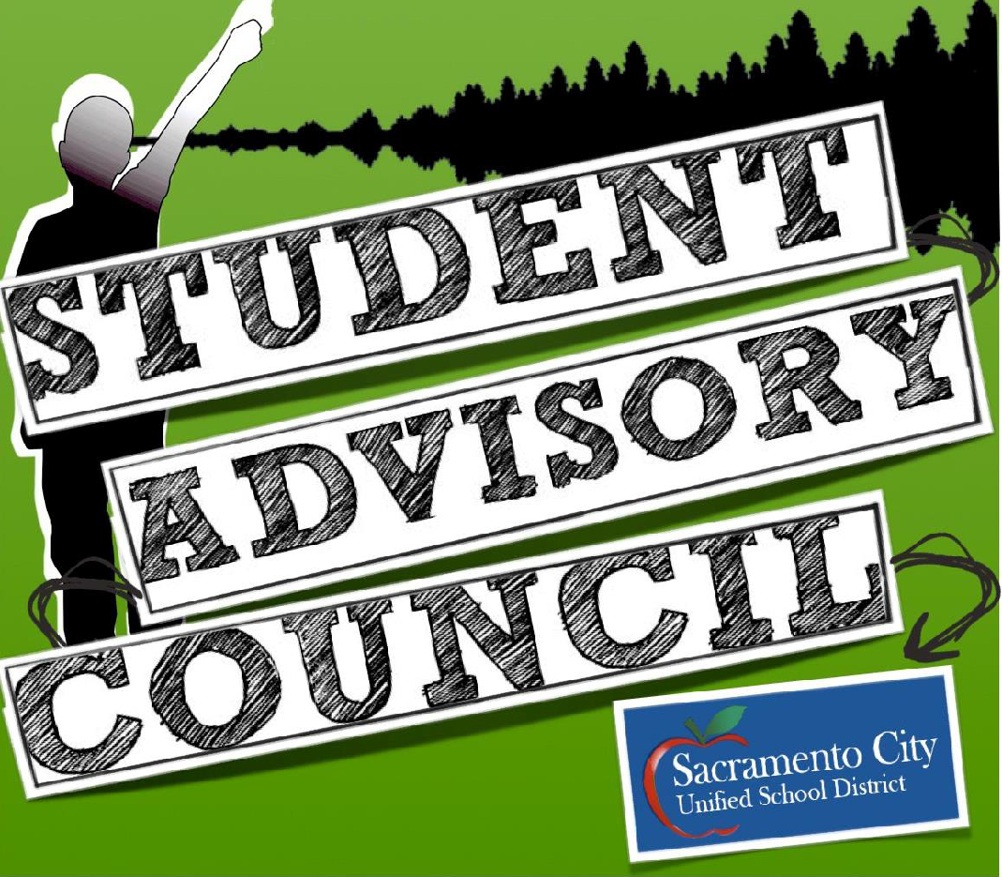
This application packet will be used for building a candidate pool for 2020-2021 Student Advisory Council (SAC). This application will be used to select (1) future Student Board Member and (13) SAC Delegates for the 2020-2021 school year. Please review all of the pages included to gain a better understanding of the history, positions, responsibilities, and commitment necessary for applying to the SAC.
Student Advisory Council Advisor
Dr. Mark Carnero
Mark-Carnero@scusd.edu

Table of Contents

Overview of the Student Advisory Council 3
Qualifications for Applying 4
Cabinet Expectations 5
Cabinet Positions Descriptions 6
Student Board Member Position Description 6
Cabinet Representative Position Description 7
Application Procedures and Important Dates 7
Application Materials 8

Overview of the Student Advisory Council

The Student Advisory Council (SAC) is a year round program that introduces students to concepts of policy advocacy, applied social research, democratic governing, and grassroots organizing. The Student Advisory Council strives to promote student voice within the district, and works to take action against problems faced by students.
Students of the SAC program represent the vast diversity of SCUSD high school youth. SAC members range from 9th to 12th grade, vary in socio-economic background, ethnicity, religion, first language, immigration status, and experience with student government.
There are two levels within the SAC program, cabinet representatives, and delegate committees. Students earn these designations through time commitment and level of involvement.
SAC Delegates commit themselves to attending weekly meetings, working to refine their skills in critical thinking, college level research methodologies, public speaking, and youth advocacy.
SAC Delegates develop policy initiatives, meet with district staff and committees, and report to the SCUSD Board of Education. As youth advocates, they work together to ensure all student voices are represented.
SAC students are critical, passionate, and determined to advocate for all student voices across our district.

This application will be used to find candidates for 2020-2021 Cabinet positions including
(1) Student Board Member and (13) SAC Delegates
Qualifications for SAC Delegate Application

- Able to commit to the school term July 1, 2020 to June 14, 2021

- Able to commit to weekly meetings at the Serna Center on Wednesday from 4:00pm to 5:30pm

- Be at least in 10th grade by the start of the 2020-2021 school year

- Complete an interview with the current SAC Board and Adult Advisor

- Able to communicate professionally and effectively with peers and adults.

- Able to work well on teams composed of youth and adults.

- Responsible and well organized.

- Must have a signature of support from parent or guardian

- Must have a signature of support from (1) of the following people on their campus:
- Administrator
- Teacher
- Counselor

PLEASE REFER TO PG. 6 & 7 FOR SPECIFIC POSITION REQUIRMENTS
SAC Delegate Expectations

The students on the Student Advisory Council are held to the highest standards of student leadership. We expect that all SAC members exhibit respect, critical thought, creativity, and passion every day.

Additionally, the following items are contractually required of all members:

- Attend ALL SAC Meetings:
  - Weekly Council Meetings
  - and upon request, Board of Education meetings or Superintendent Round-table meetings.

- Work directly with the Council and the SAC Adult Advisor to promote authentic youth engagement at ALL SCUSD High Schools.

- Assist in the identification and implementation of youth-adult action projects and trainings.

- Make presentations and agendas for and at various meetings and trainings:
  - School Board Meetings
  - Student Community Meetings
  - Other District Council Meetings

- Assist with meeting and planning coordination.

- Act as a public relations representative for SAC.

- All position requirements outlined in the Cabinet Representative and Student Board Member page

- Complete all position specific requirements

Student Advisory Council Position Descriptions

There are only (2) types of positions on the Student Advisory Council: Student Board Member & Cabinet Representative

Student Board Member

The Student Board Member has the largest and highest profile set of responsibilities of all of the SAC Cabinet. The Student Board member serves as the public representative of the entire SCUSD student body. They are a highly visible student from SCUSD that works to ensure youth input and participation in district decision-making processes. They work closely with the SAC and the SCUSD Board of Education to ensure that the viewpoints of youth representing the diversity of SCUSD are heard in district decision-making bodies. There is only 1 Student Board Member position available.

Duties & Responsibilities:
- Attend ALL SCUSD Board of Education Meetings every 1st and 3rd Thursday from July 2020-June 2021
  - Meetings start from 6:00pm and vary in time of ending
- Attend ALL weekly SAC Meetings
- Write and present Student Board Reports to the Board of Education
  - Ensure that student voice is heard in public arenas.
- Ensure youth input is included in the development of district policies.
- Make an effort to visit all schools within the district.
- Maintain visibility and approachability at community events.
- Preside over the SAC Elections Committee, if a graduating Senior.
- All responsibilities included within the Cabinet Representative roles

Qualifications & Requirements:
- Must be at least a Junior at the start of the 2020-2021 school year
- Must complete Google Forms application & complete a separate letter of interest
- Must gather the following support:
  - Must collect (1) student club organization leaders and/or advisor signatures of support from their campus, accompanied by (1) letter of recommendation from the following unrelated Adults (ie. Coaches, teachers, employers, religious leaders, etc.) or administrator on campus
- Must complete a public presentation for candidacy
- Must have a critical eye for public policy and student rights and be able to critically analyze certain CA, federal, and local policies affecting students
- Advocate for youth and community voice, respectful, responsible, well organized, passionate and able to communicate effectively with all students, district staff, and other community members.
- Meet all expectations specified on page 5.

Cabinet Representative

Cabinet representatives are public leaders of the SAC who represent each of our 14 SCUSD high schools. They are highly visible students from SCUSD that works to ensure youth input and participation in decision-making processes. They work to ensure that school and district decision-making bodies hear the viewpoints of youth representing the diversity of SCUSD.

There are 13 Cabinet Representative positions available for the SAC. There can only be 1 Cabinet representative per school.

Duties & Responsibilities:
- Attend ALL SAC Meetings:
  - Meetings are once a week, Wednesdays from 4:00-5:30
- Share agenda setting for all Student Advisory Council meetings.
- Share facilitation of cabinet meetings.
- Share public presentation building and delivery for various meetings and trainings.
- Serve as a public relations representative for school and SAC
- Work within committees and/or task force for student initiatives
- Ensure youth input is included in the development of district policies.
- Assist in community partnership development
- Help to maintain positive social media presence of SAC
- Investigate student needs at school site and report back to SAC
- Keep SAC informed of all school updates and events
- Act as a liaison between home school and SAC cabinet

Qualifications & Requirements:

- Must be at least a Sophomore at the start of the 2020-2021 school year
- Must complete Google Forms application
  - Must provide (1) letter of recommendation: (1) letter of recommendation from the following unrelated adults (ie. Coaches, teachers, employers, religious leaders, etc.) or administrator on campus
- Advocate for youth and community voice, respectful, responsible, well organized, and outspoken
- Able to communicate effectively with all students, district staff, and other community members.
- Meet all requirements specified on page 5.

APPLICATION PROCEDURES AND IMPORTANT DATES

MAY 20, 2020 Application questions are due to Dr. Mark Carnero through google forms.

https://forms.gle/gNEtdsAV1k69tDf86

Supplementary application materials (letter of intent, letters of recommendation, and signatures) should be scanned and emailed or if necessary dropped off physically to the Serna Center at 5735 47th Ave., Sacramento Ca, 95824 (attn: Youth Development / Dr. Mark Carnero)

MAY 22, 2020 Notifications of acceptance into 2nd tier for Student Board Member & SAC candidates

MAY 27-29, 2020 ZOOM or Google interviews of 2nd tier candidates for Student Board Member & SAC candidates at the Serna Center

MAY 30, 2020 Notification of acceptance into SAC cabinet position

Student Board Member digital presentation materials due to
Dr. Mark Carnero

JUNE 1, 2020 Student Board Member Presentations and Elections via ZOOM or Google. Voting and selection conducted on day of.

APPLICATION QUESTIONS

OVERVIEW: Please complete the following questions on
https://forms.gle/gNEtdsAV1k69tDf86

DUE DATE: MAY 20, 2020

FORMAT: Each question will have a 250-word maximum response.
SCORING All Questions will be scored on a 10-point scale using the following rubric.
All applicants can earn a maximum of 30 points.
Points | Format | Content
10 | Meets all format requirements with no typos or grammatical errors | Offers candid and original youth voice, provides the reader with a real version of themselves, details their perspective as a young person with multiple identities and history, offers an argument that is thorough, thought provoking, insightful, and meaningful.
8 | Meets format requirements with very few errors and typos | Strong voice is present, answers are appropriate, offers a surface level analysis, responses are thoughtful and useful
6 | Meets format requirements with many errors and many typos | Answers are hurried, not thorough but reflect some understanding of the question.
5 and below | Does not meet format requirements with many errors and many typos | Close ended answers given with minimal explanation

*Please remember that the writing portion is only one part of the entire application. We understand that many of our applicants will have varying levels of preparation and confidence in their writing. What we want to see is honesty, creativity, and individuality.
Other factors like personal interview, leadership potential, enthusiasm, and letters of recommendation will make up the remainder of application points that will determine selection.

